**Cloudformation Assignment 3**

**Problem Statement:**

**You work for XYZ Corporation. Your team is asked to deploy similar architecture**

**multiple times for testing, development, and production purposes. Implement**

**CloudFormation for the tasks assigned to you below.**

**Tasks To Be Performed:**

**1. Use the template from CloudFormation task 1.**

**2. Add Notification to the CloudFormation stack using SNS so that you get a**

**notification via mail for every step of the stack creatation process**

Step 1

Create SNS topic

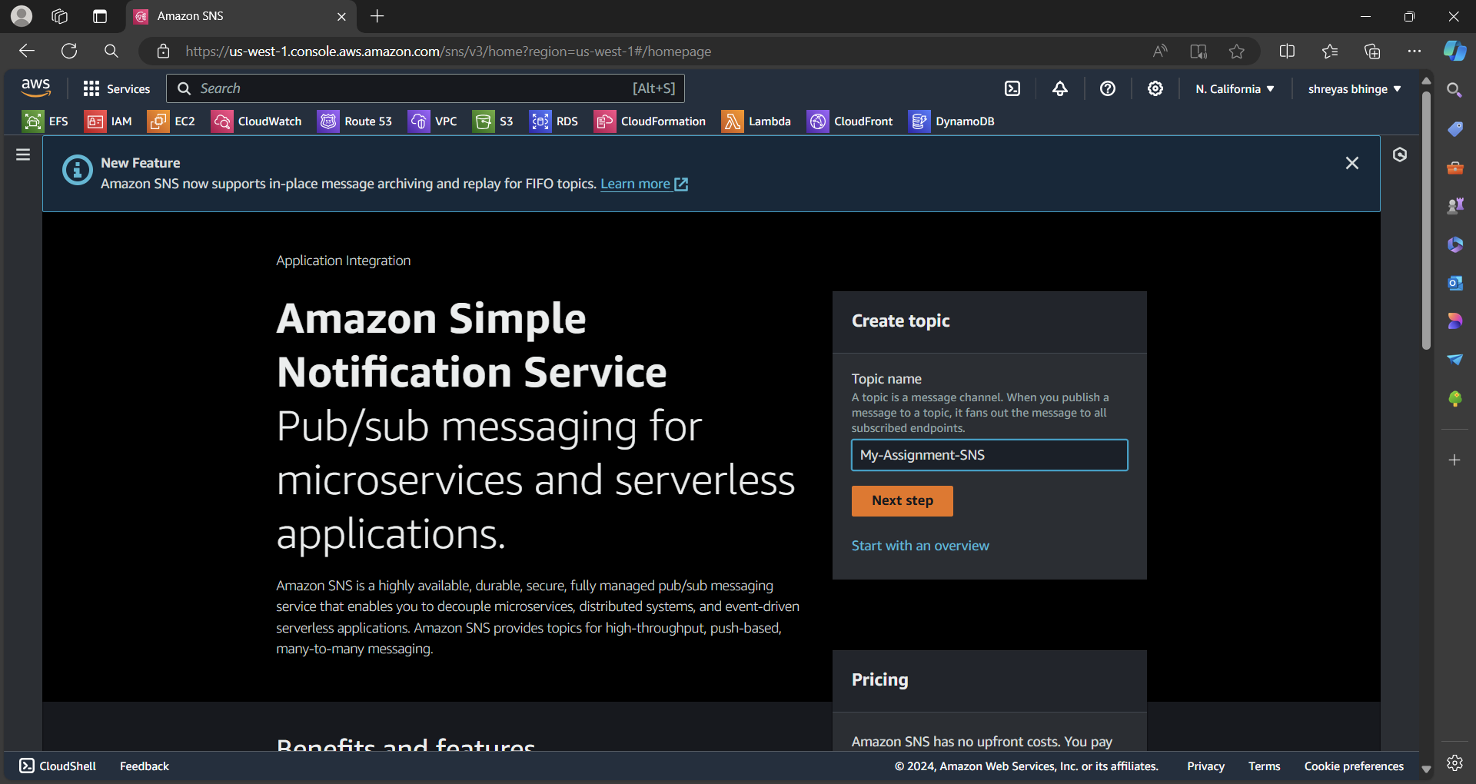

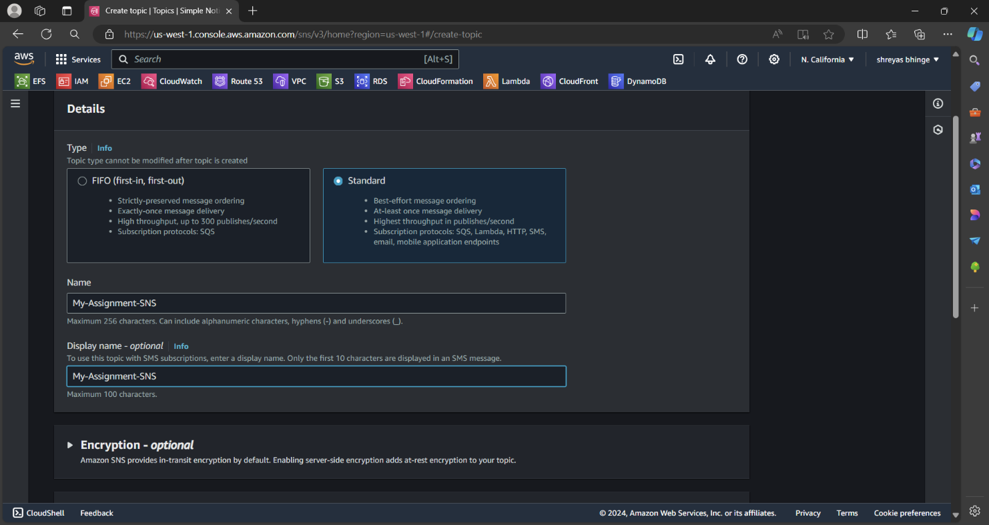

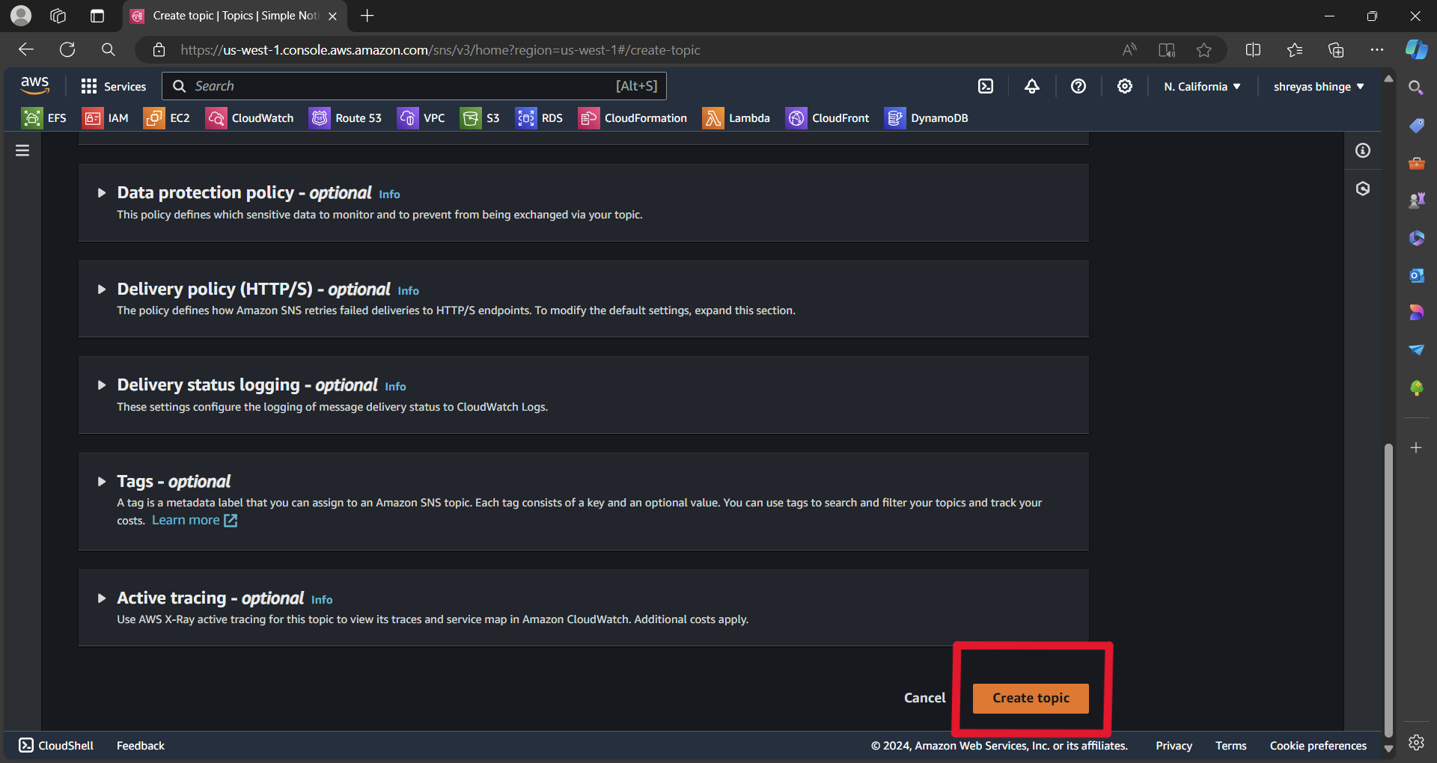

Step 2

Create Subscription

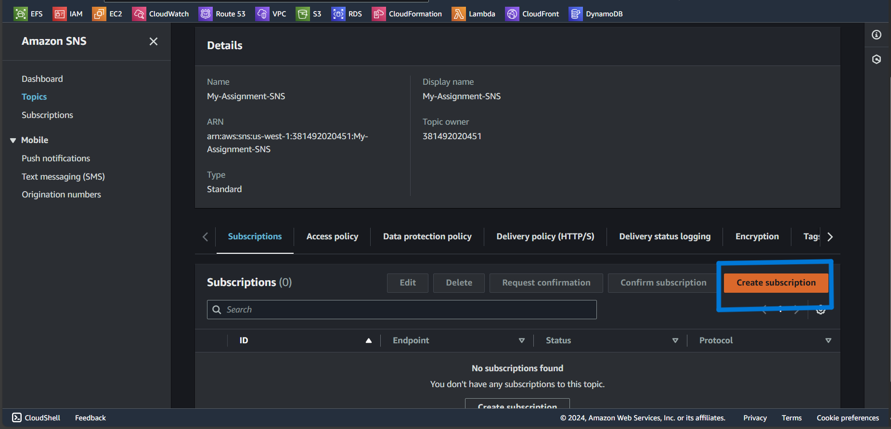

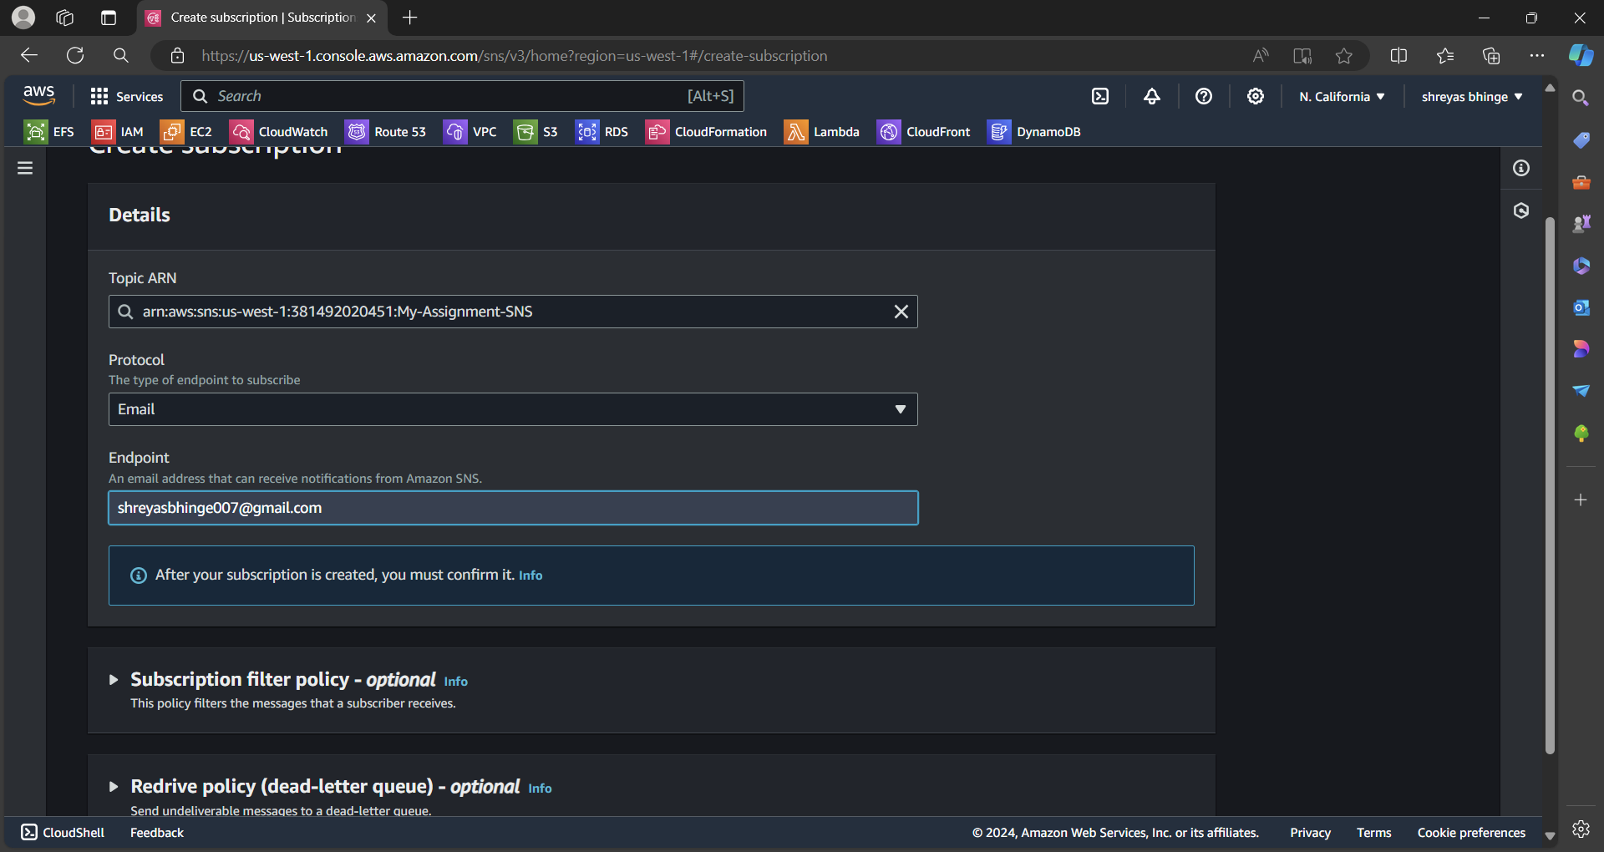

Step 3

Confirm subscription

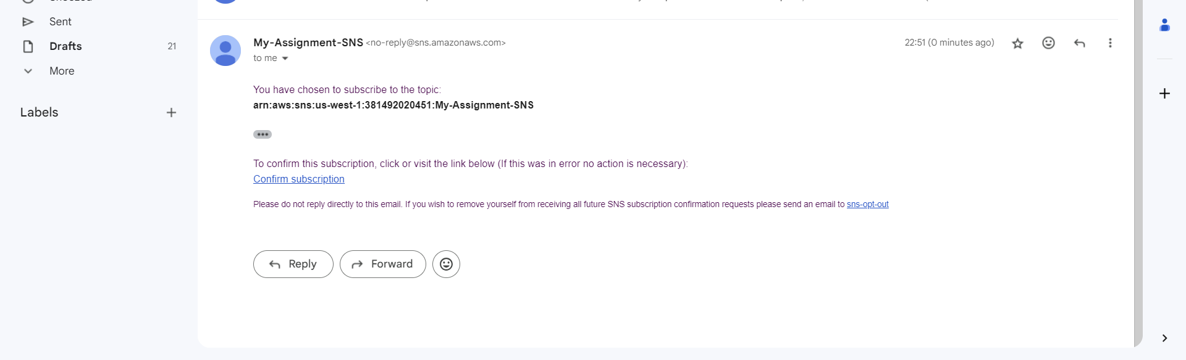

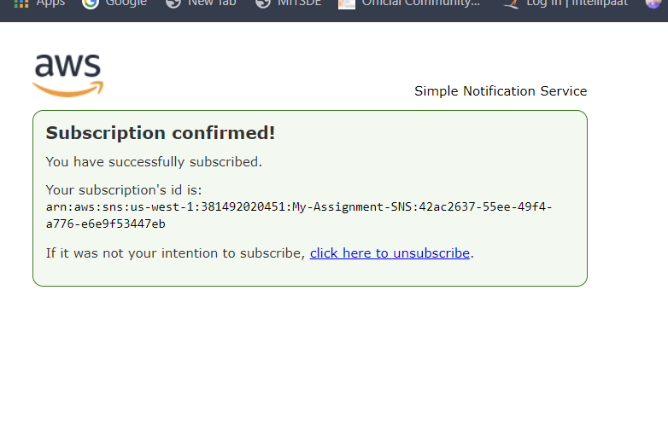

Step 4

Publish message for testing purpose

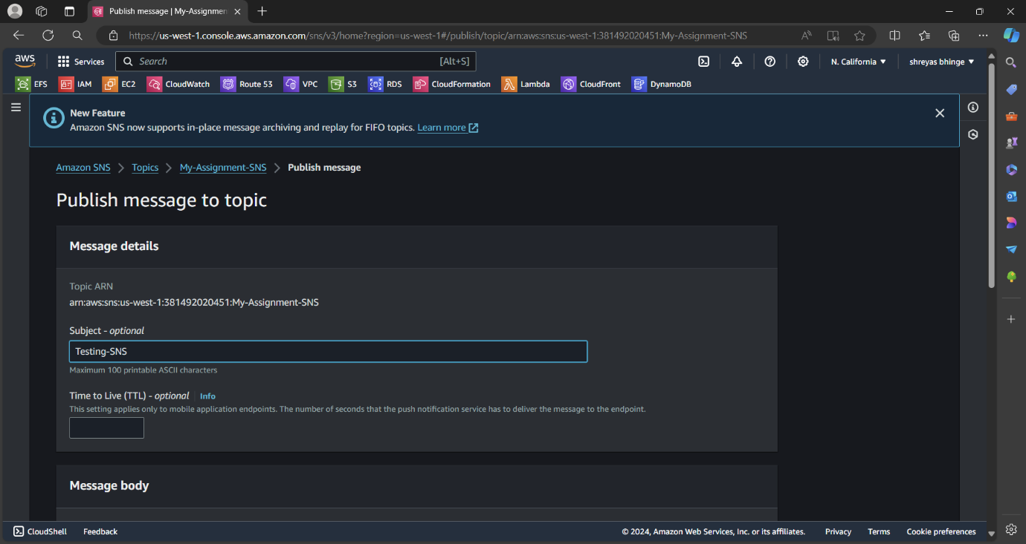

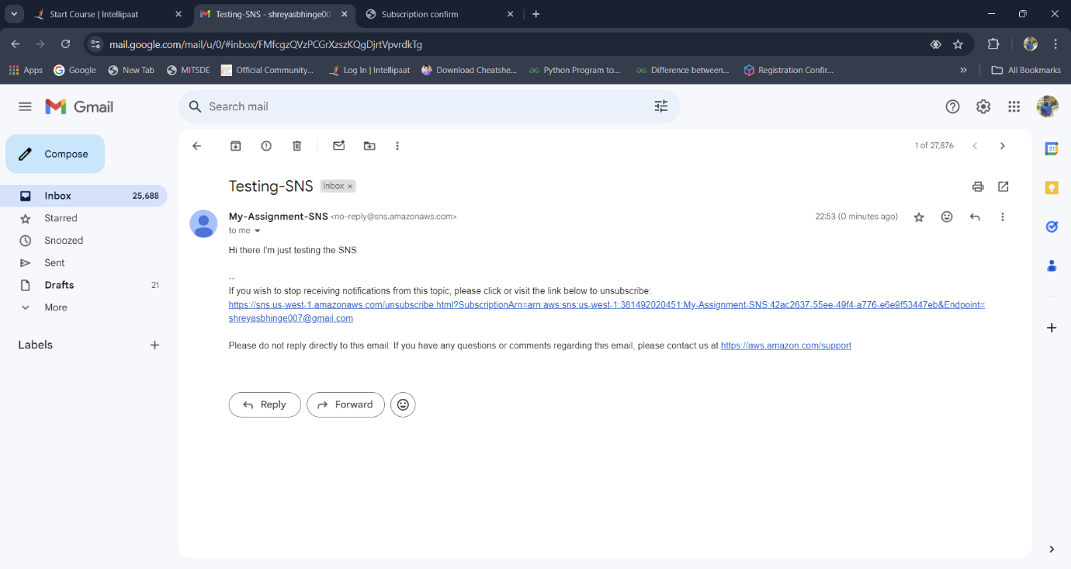

Step 5

Create CloudFormation Stack

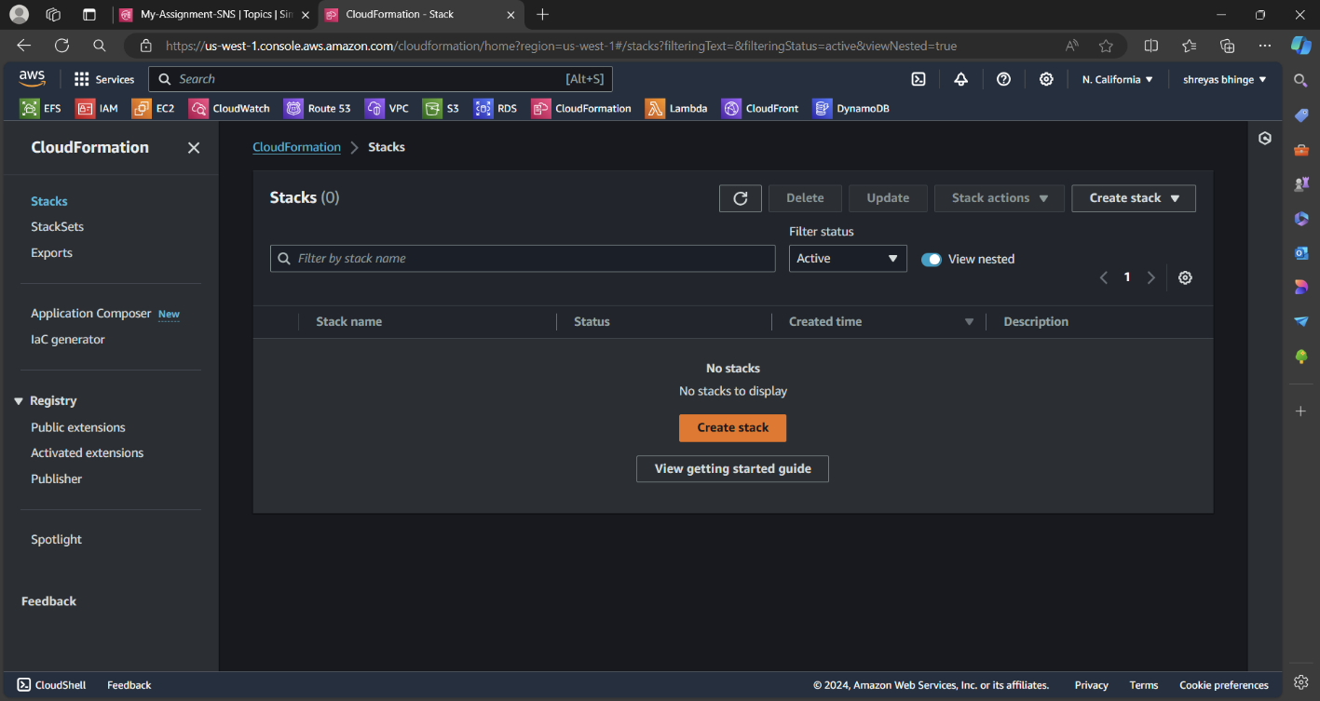

Upload the template

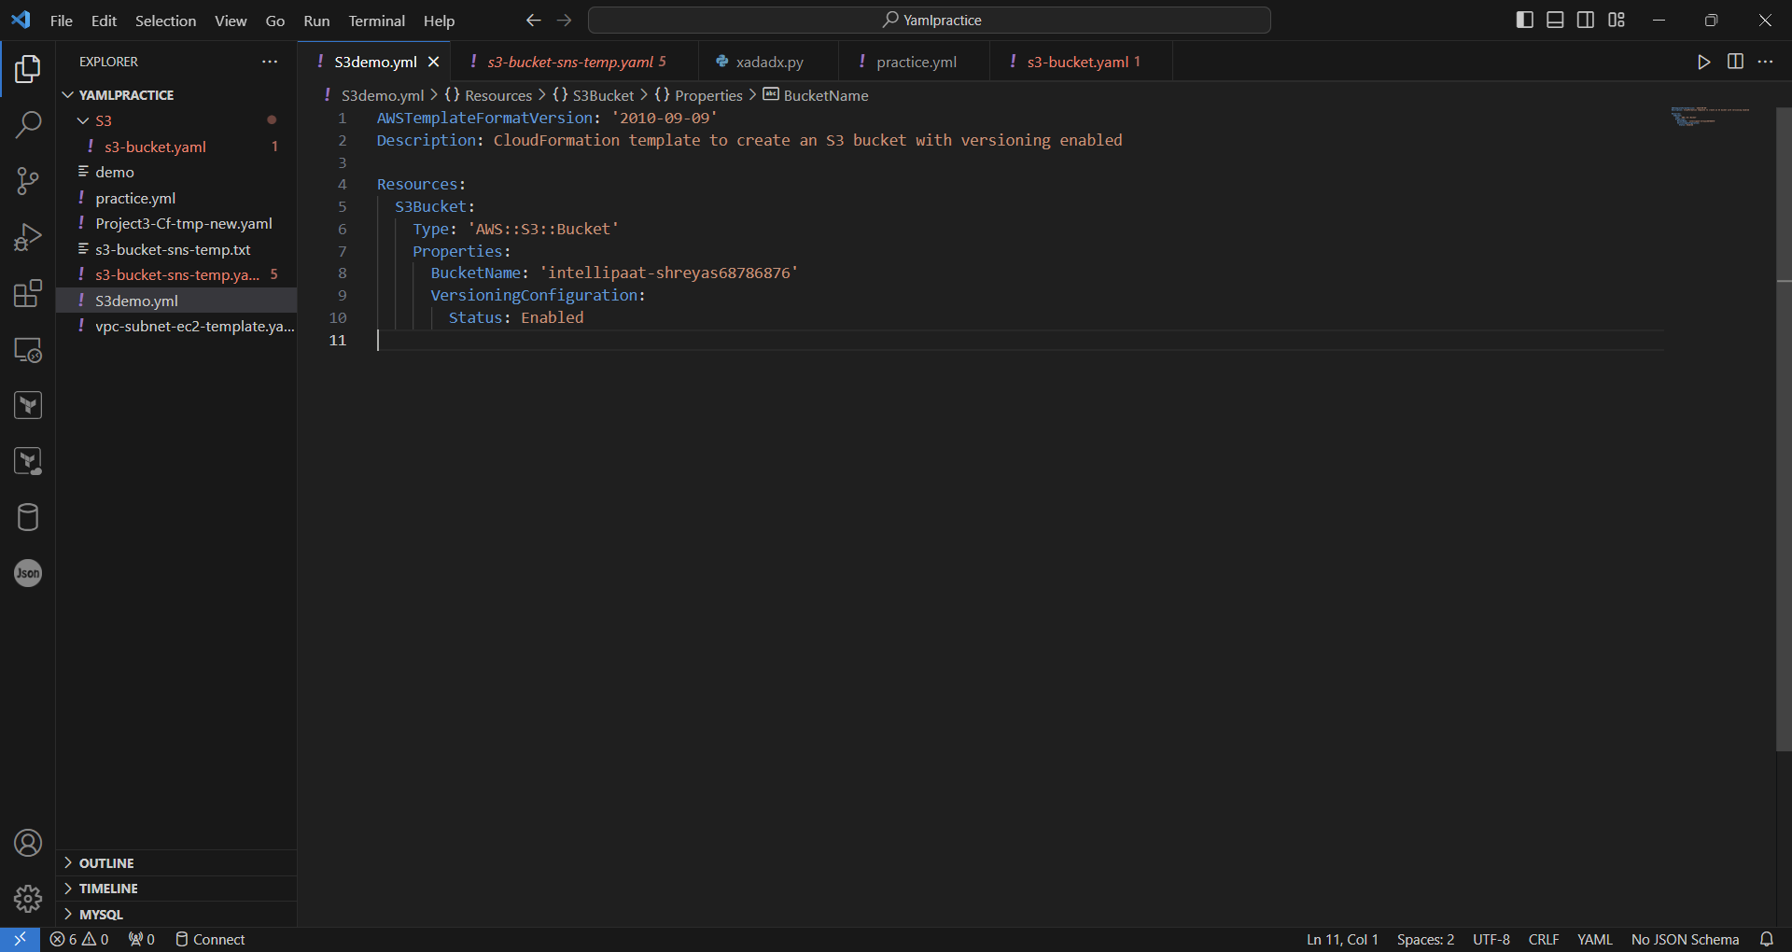

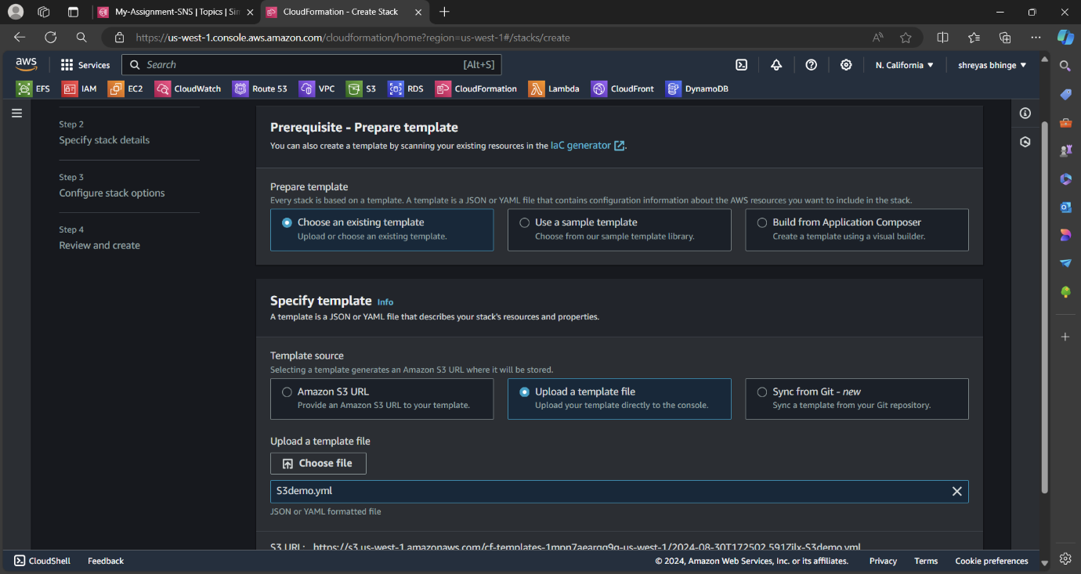

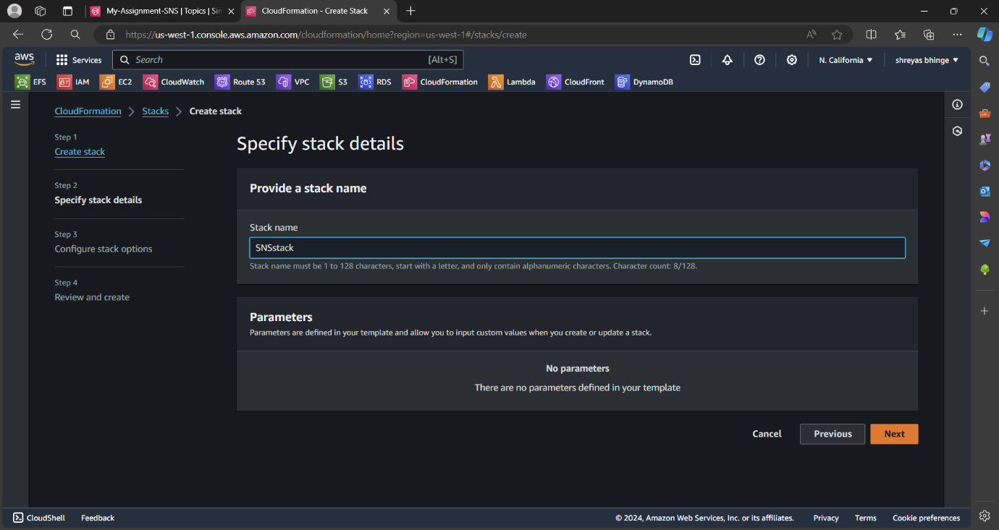

Add the SNS topic in Notification option

